Week 1 + 2
Research Linear displacement sensors

Types of sensors:
- Linear Variable Differential Transformers (LVDT)
- Ultrasonic
- Lasers
- Potentiometers
- Magnetic sensors

LVDTs:
- Linear Variable Differential Transformer
- Hollow inductor coil with rod that pushes inside, output changes based on rod position
- Infinite analog resolution (resolution is as good as ADC allows)
- More accurate ones require AC power supplies and give AC output
  - AC supply, DC output exist, so do DC/DC
  - Tradeoff is in accuracy or price
- I have been unable to locate an LVDT with digital output
- Ranges up to a few inches, one inch range is fine

Ultrasonic:
- Transducer generates signal output, receiver catches echo and calculates distance
- Generally tuned for either really long or really short distances
  - Tough to find in the 1 inch range
- Less accurate than LVDT

Lasers
- High precision
- Suitable for 1 inch range
- Expensive

Potentiometers
- Sliding contact on a rod used as a voltage divider
- Easy to incorporate into designs
- Not very accurate
- Subject to mechanical wear

Magnetic sensors (Hall effect)
- Place a magnet on device, place a receiver from measurement point, measure strength of field
- Limited range (most could be too short for our purposes)

http://www.machinedesign.com/sensors/finding-right-sensor-linear-displacement is a decent reference

For this project, I have come to the conclusion that LVDTs are the most likely sensor. Lasers are too expensive, and other sensors lack the required resolution. The draw back is that LVDTs require support electronics. At the very minimum an ADC will be required; potentially a characterizing circuit will be necessary, and at worst case an AC power supply as well. They also vary widely in price, but we're probably looking at between $400 and $1000.
I have not ordered any sensors, and am slightly behind schedule in that regard. It has taken longer to identify appropriate sensors than anticipated. At the resolution required (10⁻⁴ inches), it is difficult to find a sensor that
- Is precise enough
- Requires minimal electronics to read values from
- Is relatively inexpensive
Suitable devices are manufactured with industry in mind. I will not be using a PLC, disqualifying some sensors as they are built with PLC's in mind. It is also takes time to find the price of sensors; everyone wants me to ask for a quote, and some reply faster than others.

I have come to the conclusion that a PCB with some supporting devices will be required. I need to continue my efforts to find a suitable sensor, now knowing that I'm not getting away with avoiding PCB design.

Additionally I need to identify a pressure sensor still. This will be relatively easy, as it does not need to be precise. The application we need it to fulfill falls within the range of hobby electronics used by amateur enthusiasts, and there is a wide range of devices with existing libraries and documentation.

A simple block diagram is shown below of the intended design architecture.

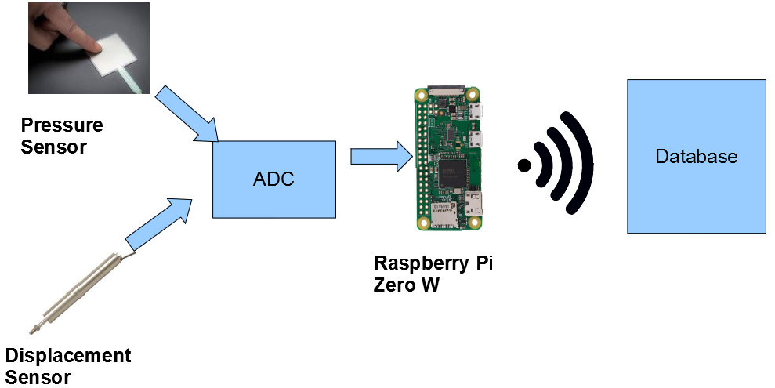
With future projects in mind, I have decided to target the Raspberry Pi Zero W as my controller. If future laboratory equipment is updated to use IoT devices, another Pi can be used. Each device costs ~$10, and has extensive documentation, guides, and existing code libraries for any purpose one could desire. Additionally, it will allow reuse of the database; code from this project could be reused to log data from arbitrary new sensors.

The Pi Zero W includes a 2.4 Ghz Wifi module. It will communicate with the existing Wifi in the soil lab, which will allow access to a database hosted using CITS' existing software (Probably some variant of mySQL). Sensors will communicate with the Pi through a custom designed PCB with at the very least an analog to digital converter (ADC).

This project is being documented on Github. Any of the files I use can be located at https://github.com/RichardMuri/Civil_IoT.
Week 3

High precision linear displacement sensors are expensive. After discussions with Dr. Fortier and Jeff Beaudry, I have decided to look at sensors with slightly less precision that are more economical as a proof of concept.

For $24 the following dial indicator is available on Amazon:

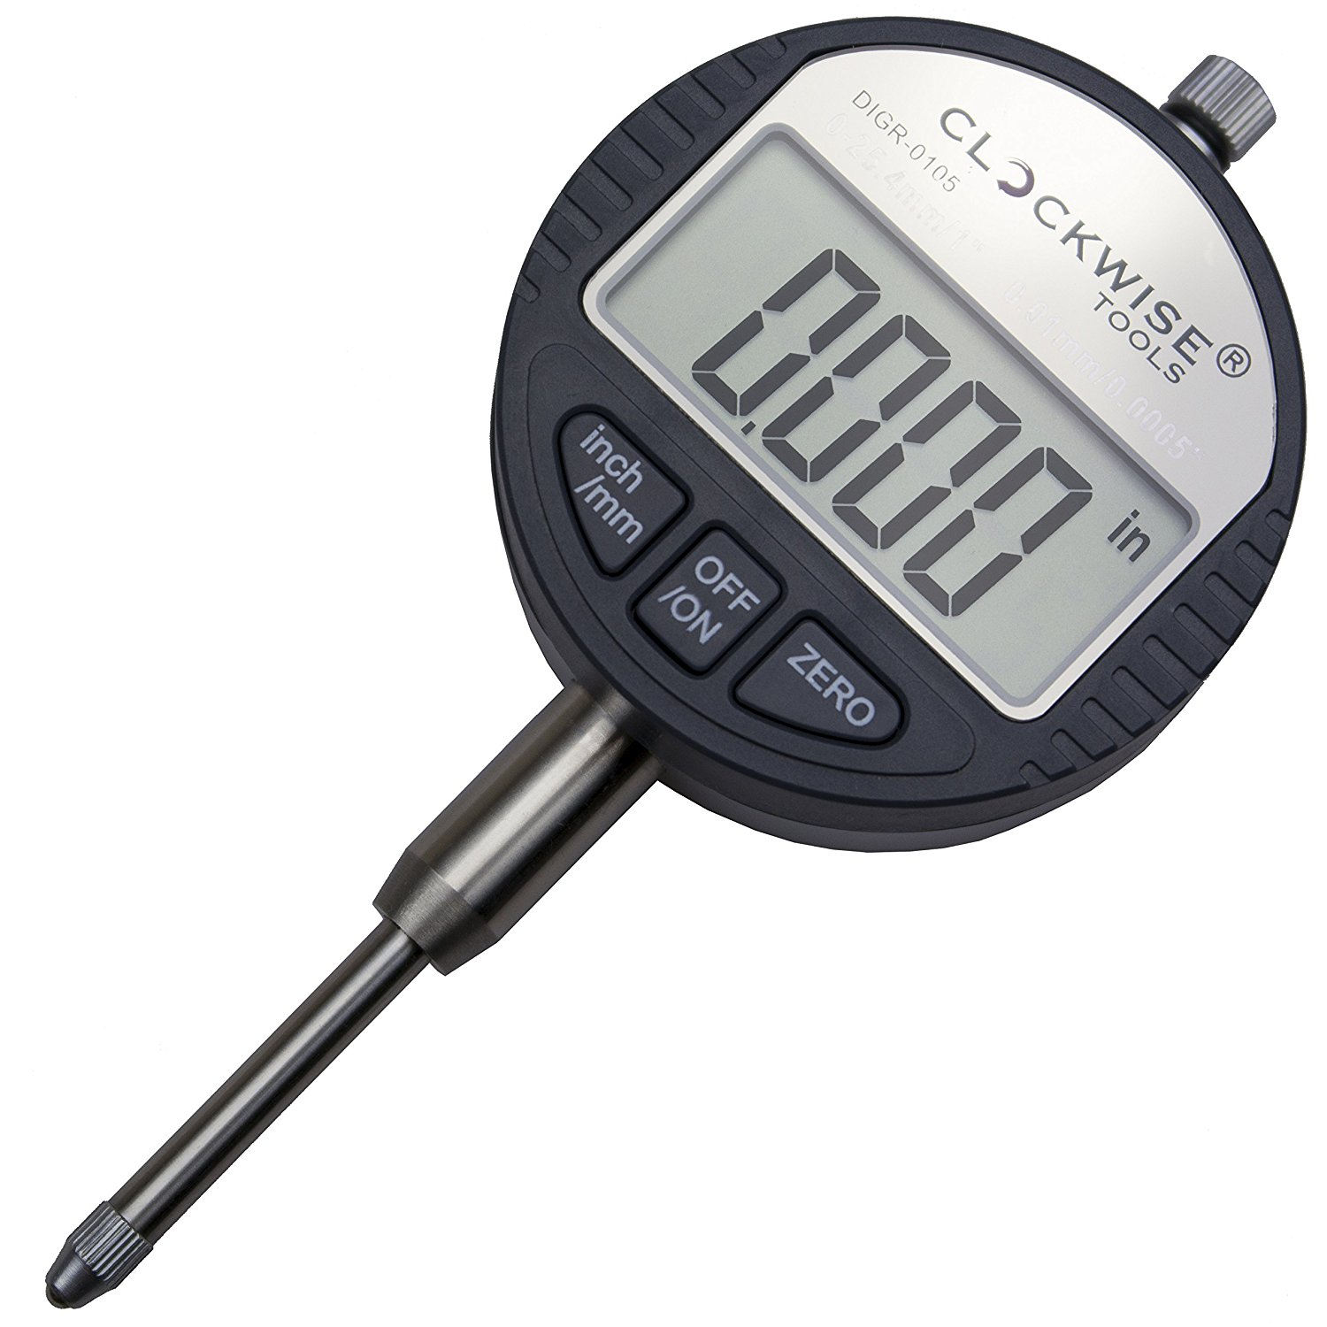

It has an accuracy of .001 inches, and a resolution of .0005 inches. It gives RS232 output, which could communicate direcly with a Raspberry Pi through the serial pins. It would require replacement of the battery with a 1.5V power supply.

I have a Pi 2 that I can use for development in the meantime while choosing what model to use as a controller. The Pi Zero W is the cheapest that can connect to Wifi at $10, assuming the WiFi signal in the lab is strong enough. If it is not, there are two options: Use a Pi 3, which has an Ethernet port, and connect via Ethernet, or plug a cheap router into one of the existing Ethernet cables in the lab. The router might be an appealing option even the Wifi signal is strong, because eduroam has certain network configurations that might make connection difficult. With my own access point, I can control everything.

For pressure sensing I intend to use a force sensitive resistor (FSR). It functions as close to an infinite resistor with no force applied, and a small value resistor with a full force applied; as more force is applied from the minimum to the maximum the resistance drops. These resistors are not accurate. Repeatability and drift are both big issues. However, for this application, we have discrete weight values and accuracy is not a concern. Pictured below is a sample FSR. I need to speak to Jeff and determine the weight values before selecting one:

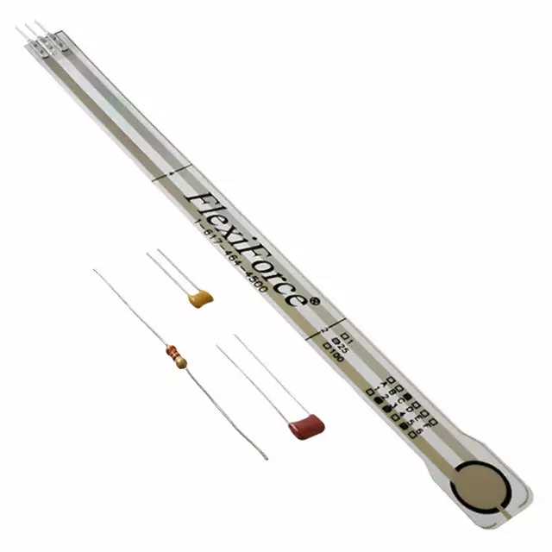

Week 4

A force sensitive resistor isn't suitable for this application. The weight range required is too high.

There are three different sized weights, the weights are directly proportional:
- 0.5 tsf - 1537g
- 1 tsf - 3074g
- 2 tsf - 6148g
The heaviest stage in the consolidation test will need 16tsf. Therefore the heaviest stage is ~49.1 kg.

The alternative is a strain gauge. A strain gauge gives output in the form of a wheatstone bridge with four wires. Shown below is a picture of how a strain gauge is attached mechanically.

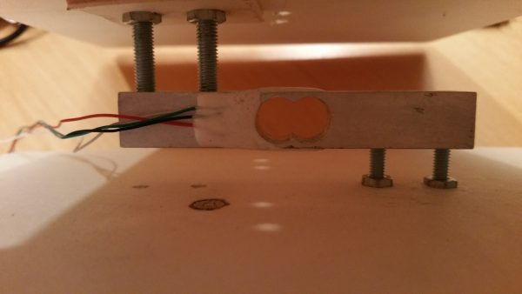

It needs to be characterized in order to use in a digital system. The chip I intend to use is a HX711 load amplifier. The example circuit from the data sheet is given below:
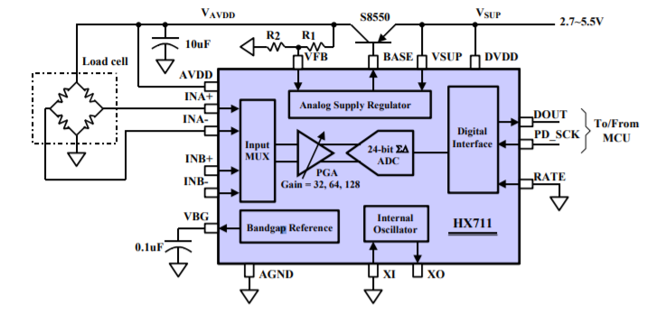
The HX711 eventually needs to be built into a PCB, which I intend to make as a "hat" for the Pi. In the interest of building a working prototype, it makes sense to order an existing breakout board. A number of boards are available for ~$2 online.

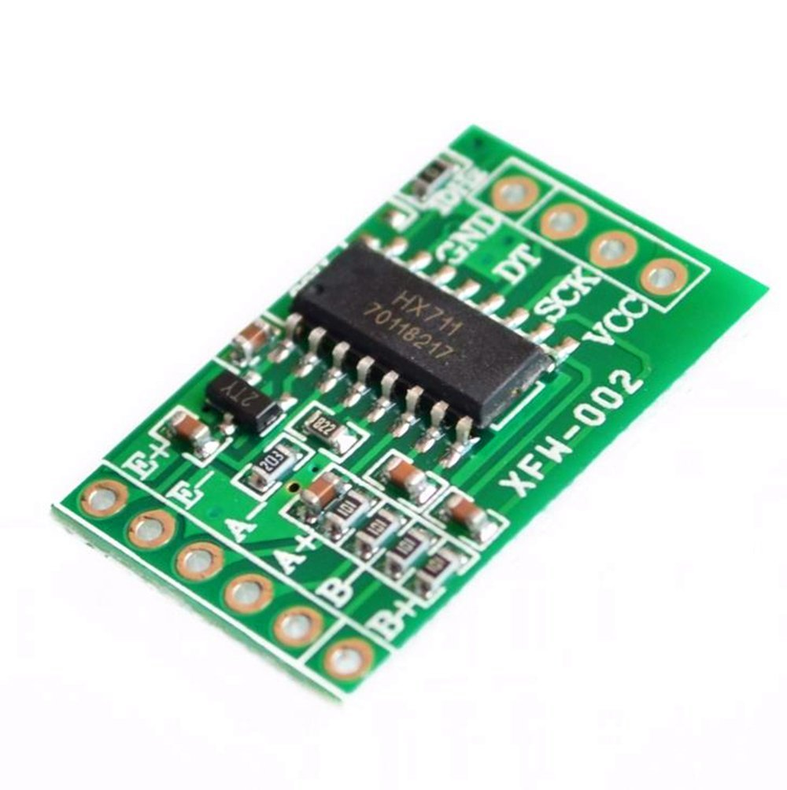

At this point I think it makes sense to order components, and build a prototype on a breadboard.

I suggest the following:

Component | Cost | Data sheet | Link
DIGR-0105 Digital Dial Indicator | $25 | Unable to find one | Amazon
Data cable for dial indicator | $37 | Unable to find one | Amazon
HX711 Load Amplifier | $10 for 5 | Data sheet | Amazon
3135 Micro Load Cell | $7 | Data sheet | Robot Shop
Raspberry Pi Zero W | $10 | Data Sheet | Adafruit

The data cable for the dial indicator may not be strictly necessary, but it does already fit the output port without having to make our own.

There will be a lead time to acquiring components. While waiting for components to arrive, I intend to begin work on the database side of the project.

